Blackfoot School District #55

Comprehensive Assessment Plan

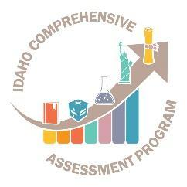
Idaho State Department of Education
Assessment & Accountability | Assessment monitoring

650 W STATE STREET, 2ND FLOOR
BOISE, IDAHO 83702
208 332 6800 OFFICE
WWW.SDE.IDAHO.GOV

TABLE OF CONTENTS
Instructions
Blackfoot School District Comprehensive Assessment Strategic Plan 2023-2024 3
Philosophy & Purpose of the State Comprehensive Assessment Program: 3
Assessment in Public Schools - Philosophy - Idaho Code §08.02.03.111.01 3
Assessment in Public Schools - Purpose -Idaho Code §08.02.03.111.02 4
LEA Assessment Philosophy/Vision 4
LEA Assessment Purpose/Mission 4
Assessments:
State and LEA Assessments 5
Testing Procedures
Table 3 – State Assessments 26
Table 4 – LEA Assessments 28
Assessment of Students with Disabilities and ELL students:
Table 5 – State Assessments 31
Table 6 - LEA Assessments 38
Professional Development:
Test Security: 41
Technology Support/ Data Quality: 43
Appendix A: Glossary 44
Appendix B: Idaho Comprehensive Assessment Program Inventory 46
Appendix C: Resources 49
The Importance of Testing: Parental Opt Out Form 51

Blackfoot School District #55 comprehensive assessment strategic plan

Blackfoot’s vision statement, mission statement, belief statements and learning goals provide the foundation for the Comprehensive Assessment System along with the District Strategic Plan and Idaho Content Standards.

Philosophy & Purpose of the State Comprehensive Assessment Program:

Assessment in Public Schools - Philosophy - Idaho Code §08.02.03.111.01
Acquiring the basic skills is essential to realization of full education, vocational and personal/social development. Since Idaho schools are responsible for instruction in the basic scholastic skills, the State Board of Education has a vested interest in regularly surveying student skill acquisition as an index of the effectiveness of the educational program. This information can best be secured through objective assessment of student growth. The State Board of Education will provide oversight for all components of the comprehensive assessment program.

Assessment in Public Schools - Purpose -Idaho Code §08.02.03.111.02
The purpose of assessment in the public schools is to:
- measure and improve student achievement;
- assist classroom teachers in designing lessons;
- identify areas needing intervention and remediation and acceleration;
- assist school districts in evaluating local curriculum and instructional practices in order to make needed curriculum adjustments;
- inform parents and guardians of their child’s progress;
- provide comparative local, state and national data regarding the achievement of students in essential skill areas;
- identify performance trends in student achievement across grade levels tested and student growth over time; and
- help determine technical assistance/consultation priorities for the State Department of Education.

The mission of Blackfoot School District No. 55, in partnership with the community, is to prepare students for the future by enabling every student to gain knowledge and skills, to develop confidence, to value life-long learning, and to become responsible contributing members of our changing world.

We believe…
• All students will be successful in school and will be able to apply knowledge to real life situations.
• All graduates will be prepared for full participation in a global environment.
• All students will complete high school with a mastery of basic life skills in reading, math, and communication.
•We must create cooperation and trust with our community stakeholders.
We will focus on increased learning:
• Students, parents, educators, and community members support one another.
• Learning should be exciting and fostered by the home, the school, and the community.
• All students and staff need an environment that develops healthy self-esteem and promotes respect for people and property.
• All students can learn.
• All students will be taught in a healthy, safe, caring, and nurturing environment.
• Curriculum should be responsive to ongoing student needs, cultural differences, and changing world conditions.

Blackfoot School District’s Assessment Purpose/Mission
Blackfoot School District supports real learning, more learning time, quality assessment aligned to standards and timely, meaningful feedback for teachers, students and parents.
Assessment Mission:
- Develop high quality, purposeful assessments.
- Utilize Edify to create assessments that include multiple item types and performance tasks.
- Secure technology that supports efficient assessment development and administration processes.
- Ensure timely delivery of assessment results.
- Develop materials and resources to enhance and support assessment literacy for all stake-holders.
- Be transparent with results.

Assessments:

State and LEA Assessments
Table 1 – State Assessments has been completed. Please complete Table 2 – LEA Assessments with the following information for locally administered assessments:

- Assessment
  - For the LEA Assessments Section, enter assessments required by the LEA.
- Grade Level
  - Specify grade level(s) for which the assessment is administered.
- Test Schedule
  - Provide the test window for the assessment.
- Purpose of Assessment
  - Describe the purpose of the assessment.
- Reporting
  - How are test results reported?
- Administration Mode
  - Specify medium through which the assessment is administered (computer, on-on-one, paper/pencil, etc.).
- Test Vendor
  - Name the test vendor, if any.

Note: Assessment types and definitions see Appendix A.

1. Assessment | 2. Grade Level | 3. Test Schedule | 4. Purpose of Assessment | 5. Reporting | 6. Administration Mode | 7. Test Vendor
Civics | Any time after grade 7 | Determined by LEA | Understand fundamentals of U.S. history & U.S. government | Transcript Required | District/School Decision | N/A
College Entrance Exam (PSAT)  *Optional* | Grade 10 | October 2, 2023 - October 21, 2023 | Practice for SAT | Scores viewable off College Board Educator Portal | Paper/Pencil | The College Board
College Entrance Exam (SAT) | Grade 11 | March 4, 2024 - April 26, 2024  *Make-Up Date April 22026, 2024 | Graduation Requirement | Scores viewable off College Board Educator Portal | Paper/Pencil | The College Board
End-of-Course Science (Biology & Chemistry | Grades 10-12 | February 26-May 18, 2024 | Assessment Of Learning | Reports available in online reporting system (ORS) | Digitally Based Assessment | American Institutes for Research
Summative Idaho Alternate Assessment (ELA/Literacy, Math, and Science) | Grades 3-8 (ELA and Math)  Science (10 and/or 11) | March 11-May 24, 2024 | Assessment Of Learning | Reports available in online reporting system (ORS) | Digitally Based Assessment | American Institutes for Research
Learner Characteristics Inventory (LCI) | Grades 3-8 and 11 | January 9, 2024 - May 24, 2024 | Assessment Of Learning | Reports available in online reporting system (ORS) | Digitally Based Assessment | American Institutes for Research
Student Response Check (SRC) | Grades 3-8 and 11 | January 9, 2024 - May 24, 2024 | Assessment Of Learning | Reports available in online reporting system (ORS) | Digitally Based Assessment | American Institutes for Research
Idaho English Language Proficiency Assessment (ELPA) – WIDA Screener for Kindergarten/WIDA Screener | Grades K-12 | July 1, 2023 -June 30, 2024 | English language proficiency for program eligible English language learners | Score reports are in WIDA-AMS/DRC system | Digitally Based Assessment  *Paper/Pencil available | Data Recognition Corporation
English Learner Proficiency Assessment – WIDA ACCESS | Grades K-12 | January 29, 2024 – March 8, 2024 | Administered to all identified Multilingual learners identified as EL learners with an EL Status of L1, LE, EW. | Score reports are in WIDA-AMS/DRC system | Digitally Based Assessment  *Paper/Pencil available | Data Recognition Corporation
Idaho Reading Indicator (IRI) | Grades K-3 | Fall: August 2023,  Spring: May 2024 | Screener for Early Literacy Skills | Locally scored and reported via ISEE in October and End of year | Paper/Pencil | Idaho State Department of Education
Summative (ISAT)  ELA/Literacy, Math, and Science | Grades 3-8 and 11 | March 11-May 24, 2024 | Assessment of Learning –  Accountability  Student Growth | Reports available in online reporting system (ORS) | Digitally Based Assessment | American Institutes for Research
Interim ISAT Assessment (ELA/Literacy, Math and Science)  *Optional | Grades 3-8 and High School | September 11, 2023-February 23, 2024 | Assessment for learning | Reports available in online reporting system (ORS) | Digitally Based Assessment | American Institutes for Research
Interim ISAT ICA and SICA | Grades 9-10 | September 11, 2023 - May 24, 2024 | Assessment for learning | Reports available in online reporting system (ORS) | Digitally Based Assessment | American Institutes for Research
The National Assessment of Educational Progress (NAEP) Math and Reading | Grades 4,8, & 12 | January 29, 2024 -March 8, 2024 | National Trend | State reporting in odd years  National reporting in even years | Digitally Based Assessment | NCES
The National Assessment of Educational Progress (NAEP) Science | Grade 8 | January 29, 2024 -March 8, 2024 | National Trend | State reporting in odd years  National reporting in even years | Digitally Based Assessment | NCES
Abbreviations Key
CEE - College Entrance Exams ISAT - Idaho Standards Achievement Test PSAT– Preliminary SAT
ELPA - English Language Proficiency Assessment LCI - Learner Characteristics Inventory
IDAA - Idaho Alternate Assessment NAEP - National Assessment of Educational Progress
IRI - Idaho Reading Indicator NMSQT – National Merit Scholarship Qualifying Test
LENGTH OF IDAHO STATE ASSESSMENTS
Grade | ISAT  Science | ISAT ELA &  Math | IRI | WIDA ACCESS | WIDA  Screener | College Entrance Exams (Digital PSAT & SAT) | NAEP | IDAA  Science | IDAA ELA  & Math
K |  |  | 10  min | 1 hr*** | 1 hr***
1 |  |  | 10  min | 3 hrs | 1 hr***
2 |  |  | 10  min | 3 hrs | 1 hr***
3 |  | 4.5 hrs | 10  min | 3 hrs | 1 hr*** |  |  |  | 1.5 hrs***
4 |  | 4.5 hrs |  | 4 hrs | 1 hr*** |  | 2 hrs |  | 1.5 hrs***
5 | 1.5 hrs | 4.5 hrs |  | 4 hrs | 1 hr*** |  |  | 1.5 hrs*** | 1.5 hrs***
6 |  | 4:45 |  | 4 hrs | 1 hr*** |  |  |  | 1.5 hrs***
7 |  | 4:45 |  | 4 hrs | 1 hr*** |  |  | 1.5 hrs*** | 1.5 hrs***
8 | 1.5 hrs | 4:45 |  | 4 hrs | 1 hr*** |  | 2 hrs |  | 1.5 hrs***
9 |  |  |  | 4 hrs | 1 hr***
10 |  |  |  | 4 hrs | 1 hr*** | 2 hours** (PSAT) |  |  | 1.5 hrs***
11 | 1.5 hrs | 5.5 hrs |  | 4 hrs | 1 hr*** | 2 hours (SAT) |  | 1.5 hrs***
12 |  |  |  | 4 hrs | 1 hr*** |  | 2 hrs
** This is an optional preliminary college entrance exam.
*** Assessment times vary based on individual student characteristics and one-on-one administration.

Table 2 – Blackfoot School District Assessments
Please complete this table for locally administered assessments NOT included in the state comprehensive assessment system.
1. Assessment | 2. Grade Level | 3. Test Schedule | 4. Purpose of Assessment | 5. Reporting | 6. Administration Mode | 7. Test Vendor
AP Course Exams | 10-12 | End of Trimesters | Summative, to earn college credit | Administrators, College Board, counselors, teachers | Paper/pencil, online | Edify, ISU, NNU, CEI, CWI, CSI
Teacher created assessments (EOC’s) | K-12 | Determined by teachers, Curriculum pacing calendar | Formative, assess student knowledge and skills of standards that have been taught | Classroom teachers, Departments, and grade levels | Paper/pencil, online (Edify), informal and formal | Edify, teacher created
Teacher created assessments (midterm) | K-12 | Midterm (3 times per year, tri-mester system) | Gauge student growth | Classroom teachers, Departments, and grade levels | Paper/pencil, online (Edify), informal and formal | Edify, teacher created
Secondary Technical Skills Tests | 10-12 | As students complete programs in the CTE departments | Assess knowledge and skill, required for technical certificate | CTE teachers, Administrators | As required per course (some may be skills based hands on assessments) | CTE teachers and Certificated Program Specialists
Program Based Assessments (Math = Pearson)  (ELA=HMH) | K-12 | According to pacing calendar of given curriculum | Assess student knowledge and skills in math and reading | Classroom teachers, Interventionists, Federal Programs Director, Principals | Paper/pencil/online, informal, and formal assessments | Pearson, HMH, Edify
Aims Web Probes Reading | K= LSF, LNF  1= LSF, R-CBM  2-3= R-CBM  4-8= MAZE  K-12 (Special Ed R-CBM) | 3 times per year as a benchmark and as needed for progress monitoring. | Measure students reading fluency and comprehension skills and student growth | Classroom teachers, Interventionists, Federal Programs Director, Principals | Paper/pencil/online | Aims Web (Pearson)
Aims Web Probes Math | K= NIM  1-3 = M-Comp  4-8= M-Cap  K-12 (Special Ed M-Comp) | 3 times per year as a benchmark and as needed for progress monitoring | Measure students math fluency and math application skills and student growth | Classroom teachers, Interventionists, Federal Programs Director, Principals | Paper/pencil | Aims Web (Pearson)
STAR Enterprise | 9-12 | Screener, progress monitor, and benchmark. No less than 4 times per year | Measure student’s math and language skills. Track student growth | Classroom teachers, Interventionists, Federal Programs Director, Principals | STAR Enterprise online courses and assessments | STAR Enterprise (Renaissance)
ALEKS | 10-12 | Math Benchmark, Diagnostic, Progress Monitor | Measure students college readiness for math, provide prescriptive intervention | Classroom teachers, administrators | ALEKS online | McGraw-Hill
Imagine Learning | 6-12 (EL students) | Benchmark, progress monitor | Measure students language skills | Classroom teachers, administrators | Imagine Learning Online | Imagine Learning
Reading Mastery | K-12 Tier 2 and Tier 3 students | Placement test, level tests | Measure student reading and language ability | Classroom teachers, administrators | Paper/pencil | McGraw-Hill
Corrective Reading | 5-12 Tier 2 and Tier 3 Students | Placement test, level tests | Measure student reading and language ability | Classroom teachers, administrators | Paper/pencil | McGraw-Hill
Study Island | Grade 6 | Benchmark, progress monitor | Measure math and reading skills | Classroom teachers, administrators | Paper/pencil | Houghton Mifflin
Edgenuity | 7-12 | Benchmark, credit recovery | Various classes | Classroom teachers, administrators | Online | Imagine Learning
Core Phonics Survey | K-6 | Reading Diagnostics | Diagnose reading difficulties | Classroom teachers, administrators, Interventionists | Paper | CORE book
San Diego Quick Assessment | K-8 | Vocabulary, Reading level | Reading level | Classroom teachers, administrators, Interventionists | paper | CORE book
iStation | K-5 | Benchmark, Diagnostic, progress monitor | Reading skills | Classroom teachers, administrators, Interventionists | online | iStation
THE FOLLOWING TESTS ARE DELIVERERD BY THOSE TRAINED THROUGH OUR SPECIAL EDUCATION DEPARTMENT
BBCS-3R | Ages 3:0-6:11 | As needed | Measure student’s speech | Speech Language Pathologist, special education teacher, administrators, IEP Assessment Team | Paper/pencil | Bracken Basic Concept Scale - Receptive
BRIEF | Age 5-18 | As needed | Rates executive function | School Psychologist, Special education teacher, administrators, IEP Assessment Team | Various modalities | Behavior Rating Inventory of Executive Function
CELF-5 | Ages 5:0-21:11 | As needed | Measures language fundamentals | Speech Language Pathologist, special education teacher, administrators, IEP Assessment Team | Speaking/Writing | Clinical Evaluation of Language Fundamentals
CELF-P | Ages 3:0-6:11 | As needed | Measures language fundamentals | Speech Language Pathologist, special education teacher, administrators, IEP Assessment Team | Speaking/Writing | Clinical Evaluation of Language Fundamentals Preschool-2
EDDT | Ages 5-18 | As needed | Measures emotional state | School Psychologist, Special Education Teacher, administrators, IEP Assessment Team | Various modalities | Emotional Disturbance Decision Tree
EOWPTC-4 | Ages 2:0-70+ | As needed | Language | Speech Language Pathologist, special education teacher, administrators, IEP Assessment Team | Speaking | Expressive One-Word Vocabulary Test
GARS-3 | Ages 3-22 | As needed | Autism | School Psychologist, Special Education Teacher, administrators, IEP Assessment Team | Various modalities | Gilliam Autism Rating Scale
GFTA-3 | Age 2:0 – 21:11 | As needed | Speech/language | Speech Language Pathologist, special education teacher, administrators, IEP Assessment Team | Speaking | Goldman-Fristoe Test of Articulation
KABC-II | Ages 3:0 – 21:11 | As needed | Intelligence | School Psychologist, Special Education Teacher, administrators, IEP Assessment Team | Various modalities | Kaufman Assessment Battery for Children
PLS-5 | Age birth-7:11 | As needed | Language | Speech Language Pathologist, special education teacher, administrators, IEP Assessment Team | Speaking | Preschool Language Scales
PPVT-4 (A,B) | Ages 2:6-90+ | As needed | Language | Speech Language Pathologist, special education teacher, administrators, IEP Assessment Team | Speaking | Peabody Picture Vocabulary
ROWPVT-4 Spanish-Bilingual | Ages 2:0 – 70+ | As needed | Language | Speech Language Pathologist, special education teacher, administrators, IEP Assessment Team | Various modalities | Receptive One-Word Vocabulary Test
SIB-R | Ages 2-99 | As needed | Skills | School Psychologist, Special Education Teacher, administrators, IEP Assessment Team | Various modalities | Adaptive Assessment
SPELT-3 | Ages 4:0 – 9:11 | As needed | Language | Speech Language Pathologist, special education teacher, administrators, IEP Assessment Team | Speaking | Structured Photographic Expressive Language Test
SSI-4 | Ages 2:10-+ | As needed | Language | Speech Language Pathologist, special education teacher, administrators, IEP Assessment Team | Speaking | Stuttering Severity Instrument
Told-P | Ages 4-8:11 | As needed | Language Development | Speech Language Pathologist, special education teacher, administrators, IEP Assessment Team | Language | Test of Language Development-Primary
TOPL-2 | Ages 6-18:11 | As needed | Language | Speech Language Pathologist, special education teacher, administrators, IEP Assessment Team | Language | Test of Pragmatic Language
TOPS | Ages 6-11 | As needed | Cognitive development | Speech Language Pathologist, special education teacher, administrators, IEP Assessment Team | Various modalities | Test of Problem Solving-Elementary
UNIT (Nonverbal) | Ages 5:0-21 | As needed | Intelligence | School Psychologist, Special Education Teacher, administrators, IEP Assessment Team | Various modalities | Universal Nonverbal Intelligence Test
WISC-V | Ages 6:0-16:11 | As needed | Intelligence | School Psychologist, Special Education Teacher, administrators, IEP Assessment Team | Various modalities | Wechsler Intelligence Scale for Children
WJ-IV Cognitive | Ages 2 and up | As needed | Intelligence | School Psychologist, Special Education Teacher, administrators, IEP Assessment Team | Various modalities | Woodcock Johnson Intelligence
WJ-IV Achievement | Ages 2 and up | As needed | Intelligence | School Psychologist, Special Education Teacher, administrators, IEP Assessment Team | Various modalities | Woodcock Johnson Achievement
WNV-IV (nonverbal) | Ages 4:0 – 21:11 | As needed | Nonverbal intelligence | School Psychologist, Special Education Teacher, administrators, IEP Assessment Team | Various modalities | Wechsler Nonverbal Scale of Ability
WPPSI-IV | Ages 2:6 – 7:7 | As needed | Preschool/primary intelligence | School Psychologist, Special Education Teacher, administrators, IEP Assessment Team | Various modalities | Wechsler Preschool and primary Scale of Intelligence
BDI | Ages 2.6-5 | As needed | Developmental ability | School Psychologist, Special Education Teacher, administrators, IEP Assessment Team | Various modalities | Batelle Developmental Inventory
BTBC-3 | Grades K-2 | As needed | Basic concepts | School Psychologist, Special Education Teacher, administrators, IEP Assessment Team | Various modalities | Boehm Test of Basic Concepts-3
TUCL-3 | Ages 3:0-9:11 | As needed | Auditory Comprehension | School Psychologist, Special Education Teacher, administrators, IEP Assessment Team | Auditory | Test for Auditory Comprehension of Language 3
LPT | Ages 5:0-11:11 | As needed | Language | Speech Language Pathologist, special education teacher, administrators, IEP Assessment Team | Paper/pencil | Language Processing Test: Elementary
LCT-2 | Ages 6:0 – 11:11 | As needed | Listening skills | School Psychologist, Special Education Teacher, administrators, IEP Assessment Team | Various modalities | The Listening Comprehension Test-2
WT-2 (Adolescent) | Ages 12:0 -17:11 | As needed | Language | School Psychologist, Special Education Teacher, administrators, IEP Assessment Team | Paper /pencil | The Word Test-2 Adolescent
WT-3 (Elementary) | Ages 6:0 – 11:11 | As needed | Language | School Psychologist, Special Education Teacher, administrators, IEP Assessment Team | Paper/pencil | The Work Test-3 Elementary
EOWPVT-4 (Spanish-Bilingual | Ages 2:0 – 70+ | As needed | Language | School Psychologist, Special Education Teacher, administrators, IEP Assessment Team | Auditory/paper/pencil | Expressive One Word Picture Vocabulary Test-4: Spanish-Bilingual
EVT | Ages 2.5-90+ | As needed | Vocabulary | School Psychologist, Special Education Teacher, administrators, IEP Assessment Team | Paper/pencil | Expressive Vocabulary Test
TEEM | Ages 3.0 – 8.0 | As needed | language | School Psychologist, Special Education Teacher, administrators, IEP Assessment Team | Paper/pencil | Test for Examining Expressive Morphology
SCAN 3 for Children | Ages 5.0 – 11:11 | As needed |  | School Psychologist, Special Education Teacher, administrators, IEP Assessment Team | Paper/pencil | SCAN 3 for Children
SCAN 3 for Adolescents and Adults | Ages 12:0 + | As needed |  | School Psychologist, Special Education Teacher, administrators, IEP Assessment Team | Paper/pencil | SCAN 3 for Adolescents and Adults
BASC-2 | Ages 6-25 | As needed | Behavior | School Psychologist, Special Education Teacher, administrators, IEP Assessment Team | Various modalities | Behavior Assessment System for Children 2nd Edition
Conners | Ages 6-18 | As needed | ADHD | School Psychologist, Special Education Teacher, administrators, IEP Assessment Team | Various modalities | Conners Scale for ADHD
CTOPP | Ages 5-24 | As needed | language | School Psychologist, Special Education Teacher, administrators, IEP Assessment Team | auditory | Comprehensive Test of Phonological Processing
ABES-R2 | Ages 4-18 | As needed | Behavior | School Psychologist, Special Education Teacher, administrators, IEP Assessment Team | Various modalities | Adaptive Behavior Evaluation Scale Revised 2nd Edition
Stanford-Binet 5 | Ages 2-85+ | As needed |  | School Psychologist, Special Education Teacher, administrators, IEP Assessment Team | Various modalities | Stanford-Binet 5
Woodcock Munoz | Ages 3-22:11 | As needed | language | School Psychologist, Special Education Teacher, administrators, IEP Assessment Team | Various modalities | Woodcock Munoz
WJ-IV Oral Language | Ages 5-18 | As needed | Oral language | School Psychologist, Special Education Teacher, administrators, IEP Assessment Team | Various modalities | Woodcock Johnson IV Oral Language
WRAML-2 | Ages 5-90 | As needed | Short-term Memory | School Psychologist, Special Education Teacher, administrators, IEP Assessment Team | Various modalities | Wide Range Assessment of Memory and Learning 2nd Edition
ADHD Rating Scale-IV | Ages 5-18 | As needed | ADHD | School Psychologist, Special Education Teacher, administrators, IEP Assessment Team | Various modalities | ADHD Rating Scale-IV
DAS-2nd Edition | Ages 2:6 – 17:11 | As needed | Cognitive Ability | School Psychologist, Special Education Teacher, administrators, IEP Assessment Team | Various modalities | Differential Ability Scales, 2nd Edition
NEPSY-2 | Ages 3-16 | As needed | Neuropsychological ability | School Psychologist, Special Education Teacher, administrators, IEP Assessment Team | Various modalities | Developmental Neuropsychological Assessment
CMS | Ages 5-16 | As needed | Cognitive ability | School Psychologist, Special Education Teacher, administrators, IEP Assessment Team | Various modalities
KTEA-3 | Ages 4-25:11 | As needed | Academic ability | School Psychologist, Special Education Teacher, administrators, IEP Assessment Team | Various modalities | Kaufman Test of Educational Achievement 3rd Editions
NNAT | Ages 5-17 | As needed | Nonverbal language skills | School Psychologist, Special Education Teacher, administrators, IEP Assessment Team | Various modalities | Naglieri Nonverbal Ability Test

Testing Procedures

Table 3 – State Assessments
In this table, identify the staff (by position) responsible and/or describe the processes for the following:
Assessment | Establishing test schedules | Ordering materials or uploading pre-identification file(s) | Identifies and trains proctors | Handling printed materials, including ordering, storing and returning.
Civics | High School Counselor/ Social Studies Department | High School Counselor/ Building Test Coordinator/Instructional Coach | High School Counselor/ Building Test Coordinator/ Instructional Coach | High School Counselor/ Building Test Coordinator, Social Studies Department
College Entrance Exam (PSAT) | High School Counselor/ Building Test Coordinator | High School Counselor/ Building Test Coordinator | High School Counselor/ Building Test Coordinator | High School Counselor/ Building Test Coordinator
College Entrance Exam (SAT) | High School Counselor/ Building Test Coordinator | High School Counselor/ Building Test Coordinator | High School Counselor/ Building Test Coordinator | High School Counselor/ Building Test Coordinator
End-of-Course Science (Biology & Chemistry) | Building Test Coordinators, Principals, Science Teachers | Building Test Coordinators, Principals, Science Teachers | Building Test Coordinators, Principals, Science Teachers | Building Test Coordinators, Principals, Science Department Staff
Idaho Alternate Assessment | Special Education Director, SpEd Consulting Teacher | Special Education Director, SpEd Consulting Teacher | Special Education Director, SpEd Consulting Teacher | Special Education Director, SpEd Consulting Teacher
Idaho English Language Assessment (WIDA’s ACCESS 2.0) | District Test Coordinator/Federal Program’s Director | District Test Coordinator, Federal Programs Director, Instructional Tech Coach | District Test Coordinator, Federal Programs Director | District Test Coordinator, Federal Programs Director, EL Staff
Idaho Reading Indicator (IRI) | District Test Coordinator, Federal Programs Director, Principals | District Test Coordinator, Federal Programs Director, Principals | District Test Coordinator, Federal Programs Director | District Test Coordinator, Federal Programs Director, Principals
Idaho Standards Achievement Test (ISAT) | Building Test Coordinators, Principals | Building Test Coordinators, Principals, Instructional Tech Coach | Building Test Coordinators,  Principals, Federal Programs Director | Building Test Coordinators, Principals
Interim Assessment | Building Test Coordinators, Principals, Federal Programs Director | Building Test Coordinators, Principals, Federal Programs Director | Building Test Coordinators, Principals, Federal Programs Director | Building Test Coordinators, Principals, Federal Programs Director
The National Assessment of Educational Progress (NAEP) | Building Test Coordinator, Principals, Federal Programs Director | Principals, Instructional Tech Coach | State NAEP Personnel | Principals, NAEP Personnel

Table 4 – LEA Assessments
In this table, identify the staff (by position) responsible and/or describe the processes for the following:
Assessment | Establishing test schedules | Ordering materials or uploading pre-identification file(s) | Identifies and trains proctors | Handling printed materials, including ordering, storing and returning.
Aims Web Benchmarks/Progress Monitoring | Federal Programs Director/Curriculum Director, Principals | Principals, Federal Programs Director, Instructional Tech Coach | Federal Programs Director, Principals, Interventionists | Federal Programs Director, Principals (Teachers do the progress monitoring. Instructional Coach may help with input of data. Data is in EdHub and Aims)
STAR Reading/ Math | Secondary Principals | Federal Programs Director, Principals, Instructional Tech Coach | Secondary Principals, Interventionists | Secondary Principals, STAR Assessments are given and monitored by the Advisory Teacher at the secondary level.
Core Phonics Survey | Federal Programs Director, Principals | Federal Programs Director, Interventionists | Federal Programs Director/ Interventionists | Principals, Instructional Coaches. (Teachers use the Core Phonics Survey if they need more information than what AIMS Web can provide)
San Diego Quick Assessment | Federal Programs Director, Principals | Federal Programs Director, Interventionists | Interventionists/Federal Programs Director | Principals, Instructional Coaches (Teachers use this for upper elementary students to get a reading level)
Imagine Learning Benchmark | Federal Programs Director/District Testing Coordinator, Principals | Federal Programs Director/District Testing Coordinator, Instructional Tech Coach | Imagine Learning Staff, Interventionists, EL Staff | Principals, Instructional Coaches, EL Staff (K-2 ALL students are required 20 minutes per day. 3-12 is available for EL’s)
HMH Benchmarks | Curriculum Director, Principals | Curriculum Director, Instructional Tech Coach | Interventionists, Curriculum Director | Instructional Coaches, Principals, Teachers (K-6 use 3 HMH Into Reading Benchmarks to chart growth. Some use Edify to test and some do paper/pencil)
Edgenuity | Curriculum Director, Principals | Curriculum Director | Interventionists, Curriculum Director, District Tech Coach | Curriculum Director, Principals, Teachers (Secondary uses this to recover credit, online school curriculum and summer school)
iStation Benchmark | Federal Programs Director, Principals | Federal Programs Director, District Tech Coach | Federal Programs Director, iStation staff, principal | Principal, staff (Teachers use as a benchmark, progress monitor and intervention)
AP Course Exams | Curriculum Director, Principals, Universities | Curriculum Director, Principal | Principals, University Staff, District Testing Coordinator | AP Teachers, University Liaisons, Advanced Opportunities staff and Counselors work together to enroll and assess students in AP coursework.
Teacher Created EOC’s and midterm exams | Curriculum Director, Principals | Curriculum Director, Principals | Principals, Curriculum Director, Interventionists | Teachers are encouraged to use EDIFY, our online assessment program. Questions are vetted and standardized. Some teacher’s prefer paper/pencil assessments. ALL students are required to do EOC’s to show growth.
Secondary Technical Skills Certificates | Curriculum Director, CTE Staff, Principals | CTE staff | CTE staff, Certified individuals, Interventionists | Any technical certificate must be proctored by the HQT. They must meet the standards required to meet the certification.
ALEKS | Curriculum Director, Secondary Math Department, Principals | Math Department, Instructional Tech Coach | Math Department, ALEKS staff, Interventionists | Students take a placement test and are placed in an ALEKS course. It is monitored and taught by our Math Department.
Reading Mastery | Curriculum Director, principals | Federal Programs Director, Instructional Tech Coach | Federal Programs Director, RM Staff, Interventionists, McGraw-Hill staff | Reading Mastery is a Tier 2 or Tier 3 intervention. Staff is expected to follow a fidelity implementation.
Corrective Reading | Curriculum Director, principals | Federal Programs Director, Instructional Tech Coach | Federal Programs Director, CR Staff, Interventionists, McGraw-Hill staff | Corrective Reading is a Tier 2 or Tier 3 intervention for grades 3-5. Staff is expected to follow a fidelity implementation.
Study Island | Curriculum Director, principal | Federal Programs Director | Federal Programs Director, Study Island staff, Interventionists | Study Island is only used at Blackfoot Heritage Sixth Grade School. This program is a Tier 2 intervention.

Assessment of Students with Disabilities and ELL students:

Table 5 – State Assessments
Briefly describe each State assessment with the following information below:Assessment | Procedures for the LEA has in place to ensure the inclusion of students with disabilities in the state assessment system | Procedures for the LEA has in place to ensure the inclusion of all English learners in the assessment system | The process for determining whether to  assess a student on the general assessment  without accommodation(s), the general  assessment with accommodation(s), or an alternate assessment | The process for ensuring the appropriate accommodations are available for Students with disabilities or English learners
Civics | Building principals, the Federal Programs Director, and the Special Education Director have the responsibility to ensure that all students are coded correctly in ISEE. Our District Tech Coach uploads the students for testing from our ISEE classes and Infinite Campus rosters. | Building principals, and the EL Director have the responsibility to ensure that all students are coded correctly in ISEE. Our District Tech Coach uploads the students for testing from our ISEE classes and Infinite Campus rosters. Students are not excluded. This is a graduation requirement. | This is the process for ALL state testing!  3 teams have a process to determine what assessment is appropriate, what accommodations and designated supports should be assigned, and/or if an alternate assessment should be used.  Team 1: Building MTSS Team  This team makes accommodation decisions for non-IEP students.  MTSS team members would include: classroom teacher, principal, MTSS team leader, parents, other teachers, EL staff, and additional support staff as needed.  Team 2: Building MTSS Team  This team determines IEP goals, whether testing is appropriate, if an alternative assessment is best for the student, and what accommodations the student will have during testing.  IEP Team members would include:  The classroom teacher, principal, MTSS team leader, parents, other teachers, EL staff, and additional support staff as needed.  If an EL student is not involved in the MTSS process the EL staff assigned to the building assembles an Accommodations Review Team to discuss and collectively decide what accommodations have been used with the student in the general education classroom and during EL intervention time. The team will decide if the accommodation should be assigned during testing. This team would consist of: EL staff, classroom teacher, additional teachers, and principal. | This is the process for ALL state testing!  If an EL student is not involved in the MTSS process the EL staff assigned to the building assembles an Accommodations Review Team to discuss and collectively decide what accommodations have been used with the student in the general education classroom and during EL intervention time. The team will decide if the accommodation should be assigned during testing. This team would consist of: EL staff, classroom teacher, additional teachers, and principal.  EL staff is responsible for uploading accommodations for EL students with WIDA testing. The Building Testing Coordinator is responsible for uploading accommodations for ISAT testing. Special Education is responsible for administering alternative assessments and uploading documents into IPASS.  The District Testing Coordinator and the principal has a copy of the accommodations entered prior to testing for all students.  Team 1: Building MTSS Team  This team makes accommodation decisions for non-IEP students.  MTSS team members would include classroom teacher, principal, MTSS team leader, parents, other teachers, EL staff, and additional support staff as needed.  Team 2: Building MTSS Team  This team determines IEP goals, whether testing is appropriate, if an alternative assessment is best for the student, and what accommodations the student will have during testing.  IEP Team members would include:  The classroom teacher, principal, MTSS team leader, parents, other teachers, EL staff, and additional support staff as needed.
College Entrance Exam (PSAT) | Building principals, the Federal Programs Director, and the Special Education Director have the responsibility to ensure that all students are coded correctly in ISEE. Our District Tech Coach uploads the students for testing from our ISEE classes and Infinite Campus rosters. The IEP specifically states if the student will participate in state testing. | Building principals, and the EL Director have the responsibility to ensure that all students are coded correctly in ISEE. Our District Tech Coach uploads the students for testing from our ISEE classes and Infinite Campus rosters. EL students are included in the uploads.
College Entrance Exam (SAT) | Building principals, the Federal Programs Director, and the Special Education Director have the responsibility to ensure that all students are coded correctly in ISEE. Our District Tech Coach uploads the students for testing from our ISEE classes and Infinite Campus rosters. The IEP specifically states if the student will participate in state testing. | Building principals, and the EL Director have the responsibility to ensure that all students are coded correctly in ISEE. Our District Tech Coach uploads the students for testing from our ISEE classes and Infinite Campus rosters. EL students are included in the uploads.
End-of-Course Science (Biology & Chemistry) | Special Education staff conduct the EOC testing of Biology and chemistry. Our District Tech Coach uploads the students for testing from our ISEE classes and Infinite Campus rosters. The IEP specifically states if the student will participate in state testing. | EL staff consult with the department teachers regarding the EOC testing of Biology and chemistry. Our District Tech Coach uploads the students for testing from our ISEE classes and Infinite Campus rosters.
Idaho Alternate Assessment | Special Education staff notify the Federal Programs Director and Special Education Director if an IEP team has determined if the student will be taking an alternative assessment. The District Tech Coach and Federal Programs Director then orders the ISAT ALT. | Special Education staff and EL staff notify the Federal Programs Director and Special Education Director if an IEP team has determined if the student will be taking an alternative assessment. The District Tech Coach and Federal Programs Director then orders the ISAT ALT.
Idaho English Language Assessment (WIDA’s ACCESS) | The EL Director and Special Education staff notify the Federal Programs Director and Special Education Director if an IEP team has determined if the student will be taking an alternative assessment. The District Tech Coach and Federal Programs Director then orders the WIDA ALT. | EL staff consult with teachers and principals regarding the EL status of students. Each trimester we review our enrollment to make sure we have all of our EL students screened and uploaded in ELMS. Our District Tech Coach uploads the students for testing from our ISEE classes and Infinite Campus rosters.
Idaho Reading Indicator (IRI) | The Principal and Special Education staff notify the Federal Programs Director and Special Education Director if an IEP team has determined if the student will be taking the IRI ALT, if a Braille test or an enlarged test is needed. The Federal Programs Director then orders the correct test. | EL staff consult with teachers and principals regarding the EL status of students. Each trimester we review our enrollment to make sure we have our EL students screened and uploaded in ELMS. Our District Tech Coach uploads the students for testing from our ISEE classes and Infinite Campus rosters.
Idaho Standards Achievement Test (ISAT) | Building principals, the Federal Programs Director, and the Special Education Director have the responsibility to ensure that all students are coded correctly in ISEE. Our District Tech Coach uploads the students for testing from our ISEE classes and Infinite Campus rosters. The IEP specifically states if the student will participate in state testing. | Building principals, and the EL Director have the responsibility to ensure that all students are coded correctly in ISEE. Our District Tech Coach uploads the students for testing from our ISEE classes and Infinite Campus rosters. Students are not excluded. This is a graduation requirement.
Interim Assessment | Building principals and Special Education Staff have the responsibility to ensure that all students are coded correctly in ISEE. Our District Tech Coach uploads the students for testing from our ISEE classes and Infinite Campus rosters. The IEP team will determine if interim assessment is given to Special Ed. students. The IEP specifically states if the student will participate in state testing. | Building principals and EL Staff have the responsibility to ensure that all students are coded correctly in ISEE. Teachers determine if they are giving the interim assessments. Our District Tech Coach uploads the students for testing from our ISEE classes and Infinite Campus rosters.
The National Assessment of Educational Progress (NAEP) | Building principals, the Federal Programs Director, and the Special Education Director have the responsibility to ensure that all students are coded correctly in ISEE. Our District Tech Coach uploads the students for testing from our ISEE classes and Infinite Campus rosters. The IEP specifically states if the student will participate in state testing. | Building principals, the Federal Programs Director, and EL Director have the responsibility to ensure that all students are coded correctly in ISEE. Our District Tech Coach uploads the students for testing from our ISEE classes and Infinite Campus rosters. If selected for NAEP students will test.

Table 6 - LEA Assessments
Briefly describe each LEA assessment with the following information below:Assessment | The LEA ensures the inclusion of students with disabilities in the LEA assessment system | Procedures for the LEA has in place to ensure the inclusion of all English Learners in LEA assessment system | The process for determining whether to  assess a student on the general assessment  without accommodation(s), the general  assessment with accommodation(s), or an alternate assessment | The process for ensuring the appropriate accommodations are available for Students with disabilities or English learners
ALL district assessments follow the same procedure regarding inclusion of test participation, administration of testing and the appropriate test assignment. | Building principals, the Federal Programs Director, and the Special Education Director have the responsibility to ensure that all students are coded correctly in ISEE. | The Federal Programs Director and EL staff have the responsibility to review the EL status of every EL student annually, update their current status, and input information into ELMS correctly. All EL staff have an updated list every trimester regarding EL students and their eligibility. According to the Home Language Survey we will screen students using the Online Screener. If the student qualifies for EL services they will be tested using the WIDA Access test. (NOTE: if an EL student is new to the country within the past 12 months they are exempt from ELA ISAT test for one year.) | 2 teams have a process to determine what assessment is appropriate, what accommodations and designated supports should be assigned, and/or if an alternate assessment should be used.  Team 1: Building MTSS Team  This team makes accommodation decisions for non-IEP students.  MTSS team members would include: classroom teacher, principal, RTI team leader, parents, other teachers, EL staff, and additional support staff as needed.  Team 2: Building MTSS Team  This team determines IEP goals, whether testing is appropriate, if an alternative assessment is best for the student, and what accommodations the student will have during testing.  IEP Team members would include:  The classroom teacher, principal, RTI team leader, parents, other teachers, EL staff, and additional support staff as needed. | If an EL student is not involved in the MTSS process the EL staff assigned to the building assembles an Accommodations Review Team to discuss and collectively decide what accommodations have been used with the student in the general education classroom and during EL intervention time. The team will decide if the accommodation should be assigned during testing. This team would consist of: EL staff, classroom teacher, additional teachers, and principal.  EL staff is responsible for uploading accommodations for EL students with WIDA testing. The Building Testing Coordinator is responsible for uploading accommodations for ISAT testing. Special Education is responsible for administering alternative assessments and uploading documents into IPASS.  The District Testing Coordinator and the principal has a copy of the accommodations entered prior to testing for all students.

Professional Development:
- Describe the process your district uses to train staff who interact with each of the State and LEA’s assessments. Provide as much detail as possible.
The Federal Program’s Director oversees testing for the district. The district has created a “Cycle of Work” that shows the definitions and reasons why assessments are given. Annually all teachers review the “Cycle of Work” in a faculty meeting. Each building assigns a Building Testing Coordinator that is trained by the Federal Program’s Director annually regarding each test. Under the direction of the principal, the Building Testing Coordinator trains the testing proctors for all testing. The Federal Program’s Director then has a “Proctor Training Make-Up day” to accommodate anyone who missed the building level proctor training. All instructional coaches are trained as well to serve as a back up to the Building Testing Coordinator.

- Describe the process your district uses to train staff supporting students with disabilities and English learners on selection of and the appropriate use of accommodations and/or designated supports
The Federal Programs Director trains the EL staff and a group of WIDA proctors annually and has a training day in which all proctors update their certification. With this training we review the Accommodations and Designated Supports area of the assessment. We identify the building teams (Team 1, Team 2 or Accommodations Review Team) that would need to approve the accommodations and designated supports for each student at the building level. Paperwork is distributed to be filled out by the team (state form) and kept on file as their decision regarding the assignment of accommodations and designated supports. These are listed on a spreadsheet that is given to the proctor’s so they can check if the accommodations are uploaded prior to the student starting a test session. This list of accommodations is also given to the District Testing Coordinator and the principal.

For Special Education students we have each building special education teacher (Team 2 Member as stated in the above chart) review the IEP and bring with them a list of the accommodations and designated supports that are documented in the IEP. We have a district form that lists the student’s name, what accommodation or designated support each student gets. Those supports are uploaded for the student and are listed on an Excel spreadsheet. The testing proctor on site then has the spreadsheet as a reference to make sure the proper accommodations and designated supports have been assigned prior to the beginning of a test session. This list of accommodations is also given to the District Testing Coordinator and the principal.

- Describe how assessment results for each state and LEA assessment are used, including the audience for the results.
Assessment results are used for many reasons.
Student: Assessments results are shared with students, so they are aware of their skill levels and the amount of growth they have made. Those assessments that are required for graduation students are made aware of their status immediately.
Parent: Results are shared with parents on all assessments both required by the State and the district. Parents have access to student test scores through Infinite Campus at any time through the parent portal. We want to be transparent with parents regarding their student’s progress. Parents also have access to unofficial transcripts through Infinite Campus, so they know if their child is on track to graduate.
Teacher: When assessments are taken online through Edify the results are immediate and disaggregated for teachers to look at learning trends, standards that students understand or don’t know. Teachers can mark growth and adjust their teaching. That is our main goal for teachers. We want them to use the assessment results to inform and help them make intentional teaching/learning opportunities for students.
Administration: We look at our data as a group every trimester to make informed decisions regarding curriculum, intervention, teacher allocation, class size, and budgeting.
Community Stake Holders: In our district we have a “Data Room” where all our testing data is displayed for patrons to come and study and ask questions. We have 3 meetings with our School Board and District PAC where we share our “Data Folder” with them. We show learning trends and how our Title funds are budgeted to meet the skill needs of our students. These meetings give the public an opportunity for input. Since we use supplemental levy money for curriculum as well, we want the public to be well informed regarding student growth and testing results.

- Describe how testing schedules are developed, who is responsible for developing testing schedules, who is responsible for communicating the testing schedule to the district and school and parents.
Testing schedules districtwide are under the direction of the Federal Program’s Director. The testing window’s that are provided by the SDE are the guide to the main schedule. Using Google Docs, the testing window is created for each test and then the principal or building testing coordinator can go in and schedule specific building testing times. This allows the tech department to manage and monitor devices that will need to be ready for testing. In the Google Doc that is shared with the administrators and tech department the date, time, place, and number of devices are listed for everyone to see. Principals know that not all buildings can test on the same day. This sign-up procedure allows our tech department to have someone on site when we start testing to help troubleshoot any hardware issues.

Our district has recorded a Parent Assessment Information Meeting. This meeting is presented by the Federal Program’s Director. It explains what assessments will be given, why the assessments are given, how to read the results letter, how to read a transcript, and why participation is important.

Test Security:
- Explain process to ensure students do not have calculators, alphabet strips, recordings, books, walls are free from instructional materials, etc. during any state testing unless items are specifically approved as accommodations.
Our testing sites are designated for testing purposes when we start testing. They are not classrooms and have only materials that follow testing guidelines. We also post at each testing site that it is considered a “testing site” and that it should remain secure and have no less than 2 proctors always present. We also require that every testing site have their testing schedule posted inside and outside of the testing site 2 days prior to testing. If any site changes are made, they must be approved by the Federal Programs Director. Students and proctors are not allowed to bring phones into the testing site.

- Describe the process used to ensure students are appropriately monitored when they are in the testing room or leave the testing room for a break.
For each testing session we have: a Test Administrator, a test proctor, and a rover. The administrator and proctor must always remain in the test session. (We keep our testing sessions to 20-25 students.) The rover can leave to accompany a student to the designated bathroom or drinking fountain. The rover can sit on a chair outside of the testing site to accompany children to bathroom etc. The rover may be a duty aide or a substitute that we have brought in just for testing purposes. Students are not allowed to go to the bathroom if other students are present during testing time. We don’t want them speaking with anyone in the bathroom regarding the test.

- Explain the process for ensuring all paper assessments and other assessment materials are handled appropriately. Include how materials are transported, stored, returned, or destroyed.
Transported: The Federal Programs Director distributes all state paper assessments. Building Test Administrators and principals must sign a district testing form that states:
The name of the test, the date received, who received it, how many tests were given, and that they will keep the materials secure according to district guidelines.
Stored: District guidelines require that tests be under a “2 lock system”. This means that the tests should be in a locked office in a locked cabinet.
Returned: The Building Test Administrator or principal returns any unused, scratch paper, and/or other test materials to the Federal Programs Director. (Whomever signed for the materials when they were delivered is the person that is authorized to return materials)
Destroyed: All materials that need to be destroyed are put in a locked shred bin at the District Office. These materials are shredded by an outside company on site.

- Provide any local policies established related to test security.
Blackfoot School District reviews the Idaho Code of Ethics prior to testing with certified and non-certified staff. Blackfoot School District participates in the security webinars offered through Caveon. We also use the TILSA Test Security Guidebook to clarify any questions we might have about test security.

For additional information on test security, please review the Assessment Integrity Guide.

Technology Support/ Data Quality:
- Describe the responsibilities of District Technology Coordinators in supporting the state and LEA assessments.
Blackfoot School District Technology Director has created the following assignments in our tech department to help manage testing and assessment for our district.

Technology Director: works with the Federal Programs Director to schedule and coordinate the logistics of testing.
Technology Coordinator: Manages the preparation of the devices for testing. (Computer updates, testing icons, sound requirements, etc.)
Technology Coach: Completes the student data uploads into the testing system. Creates rosters for SBAC Interim Assessments, uploads WIDA students, updates all online instructional platforms, class assignments, assigns AimsWeb classes, and loads students into math and reading online software. Manages EdHub data.
Technology Staff: On-site during testing to help trouble shoot hardware issues that may arise during testing.

- Describe how the LEA ensures that student information is accurate in ISEE reports. The Administrative Assistant to the Superintendent is also the District ISEE Navigator. She completes all the ISEE uploads to the SDE and corrects any errors that we may have prior to the upload. We work with our assigned ISEE Regional Navigator to correct any mistakes. Our District Technology Coordinator and our Technology Coach also work on the ISEE report to provide a check and balance system.

Appendix A: Glossary
- Assessment – The process of quantifying, describing, or gathering information about skills, knowledge or performance.
- Benchmarks – Benchmarks describe the knowledge and skills that all students should know and be able to do, in selected content areas, by the time they reach certain grade levels. Benchmarks are yardsticks or targets, because they specify the knowledge and skills within a content area’s continuum that a student must possess to demonstrate a level of progress toward mastery or proficiency of a standard. States may refer to benchmarks as competencies, anchors, etc.
- Curriculum-Embedded Assessment – Curriculum-embedded assessments are those that have been deliberately incorporated in the instructional material being used by learners or in the instructional activities routinely taking place. Examples include: Quizzes, End of Chapter Tests, and Common Assessments.
- Decode – To analyze spoken or graphic symbols of a familiar language to ascertain their intended meaning and to change communication signals into messages, as to decode body language.
- Diagnostic Assessment – Pre-assessment that allows a teacher to determine students’ individual strengths, weaknesses, knowledge, and skills prior to instruction. It is primarily used to diagnose student difficulties and to guide lesson and curriculum.
- Formative Assessment – Refers to a process that includes the following attributes: Clarify Intended Learning, Elicit Evidence, Interpret Evidence, and Act on Evidence. The formative assessment process helps teachers identify where students are in their learning so that adjustments can be made to curriculum, instructional methods, and academic support. Formative assessment activities are not graded. These activities are integrated into daily instruction and are not quite teaching, but not traditionally what we call assessment. This evidence helps both learner and teacher decide what to do next.
- Growth Targets – A state or district level target, which is set to define progress and track change in individual student achievement scores over multiple years. Used for accountability purposes.
- Interim Assessment – Assessment that educators use to (1) periodically evaluate where students are in their learning progress and (2) determine whether they are on track to master standards within a given time period. Interim assessments are usually administered strategically during a course or school year (for example, every three to six weeks) and separately from the process of instructing students. They are not graded and not used for accountability purposes.
- Norm-Reference Assessment – Comparing a student’s performance or test result to performance of other similar groups of students; (e.g., he typed better than eighty percent (80%) of his classmates.
- On-Demand Assessment – Assessment that takes place at a predetermined time and place. Quizzes, state tests, SATs, and most final exams are examples of on-demand assessment.
- Performance Assessment – Direct observation of student performance or student work and professional judgment of the quality of that performance. Good quality performance assessment has pre-established performance criteria.
- Portfolio-Based Assessment – Collections of academic work that are compiled by students and assessed by teachers in a consistent way. For example: assignments, lab results, writing samples, speeches, student-created films, or art projects.
- Proficiency – Having or demonstrating a high degree of knowledge or skill in a particular area to the extent that standards are met.
- Progress Monitoring – Progress monitoring probes are administered weekly or biweekly to gauge student growth toward mastery of a targeted skill.
- Screening – Assessment used to determine whether students may need specialized assistance or service, or whether they are ready to begin a course, grade level, or academic program. Screening assessments may take a wide variety of forms, they may be developmental, physical, cognitive, or academic.
- Summative Assessment – Summative assessments provide information regarding the level of student, program, or school success at an endpoint in time. Results are used to evaluate student achievement toward grade level standards, determine program effectiveness, and meet accountability requirements. Examples include: End of Course Assessments, ISAT Assessment.
- Universal Screening – Universal Screeners are administered one to two times per year to identify learners who may be at risk of not meeting grade level standards. Examples include: Idaho Reading Indicator, CORE MAZE, CORE Vocabulary.

Appendix B: Idaho Comprehensive Assessment Program Inventory
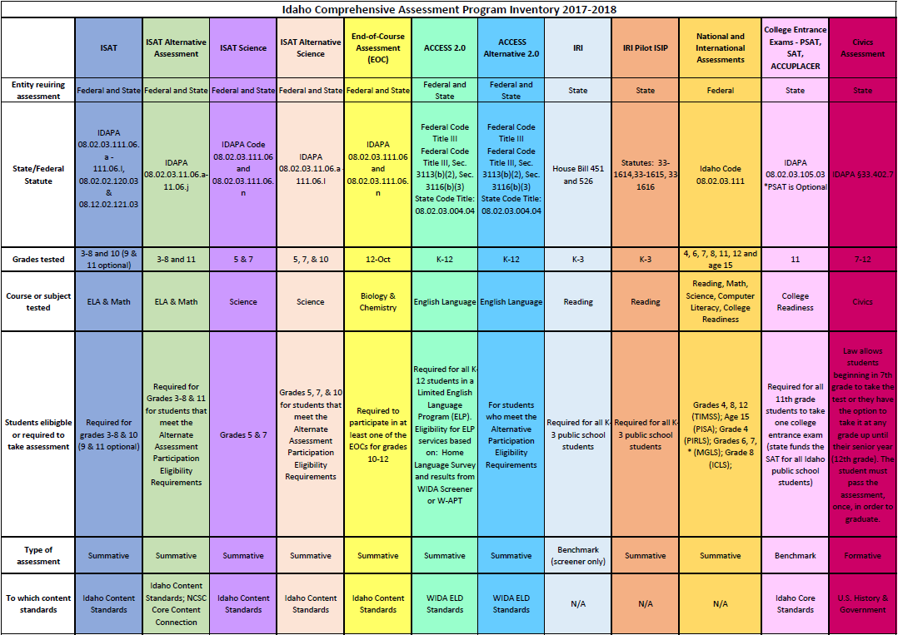
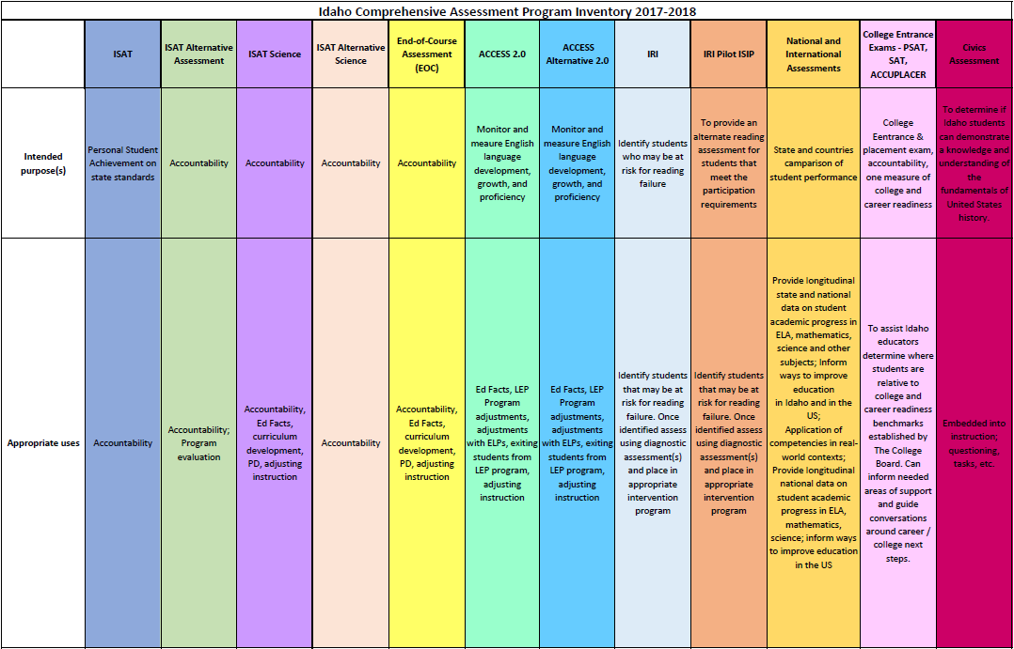

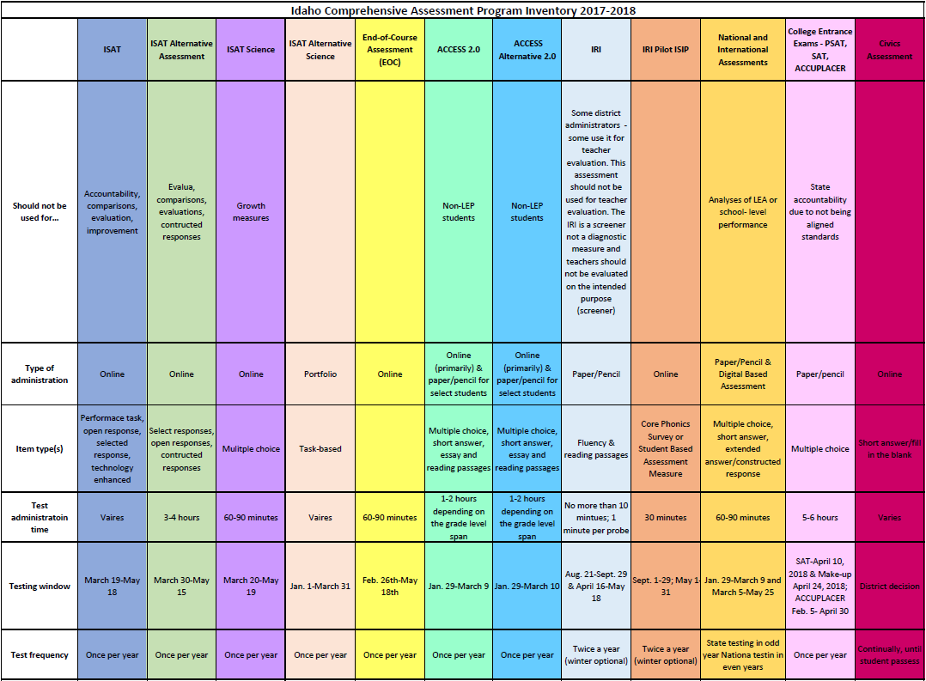
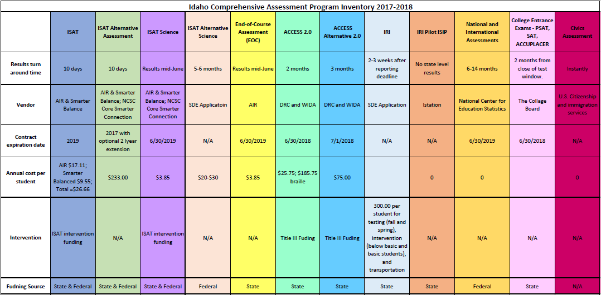

Appendix C: Resources
This list provides links to frequently accessed sites. Links to specific assessment portals or external websites are also included.
- Idaho State Department of Education Assessment and Accountability:
  - Assessment Main Page
    - Main page to navigate to each state assessment, calendar of events, resource center, and pending rule changes.
  - Resource Center
    - Archived monthly webinars and newsletters; portals for ADEA, Assessment Monitoring, Incident Log, I-Pass, IRI, ISAT, Participation Appeals, WIDA AMS; resource files, FAQs, trainings and links for each of the portals
      - Edmodo
        - Annual Test Coordinators User Group - To subscribe, contact the Assessment and Accountability department for the current code.
  - Pending Rule Changes
    - Keep up-to-date with any SDE pending rule changes
  - Civics Assessment
  - College Entrance Exams
    - College Board:
      - Main Webpage
      - SAT
      - PSAT
      - ACCUPLACER
      - ACCUPLACER Portal
  - English Language Proficiency Assessment
    - WIDA
      - WIDA Main Page
      - WIDA AMS
  - Idaho Reading Indicator
  - ISAT Comprehensive Assessment System
    - Digital Library
    - ISAT ELA
    - ISAT Math
  - Idaho System for Educational Excellence (ISEE)
  - National and International Assessments
    - National Assessment of Educational Progress (NAEP):
      - General Information
        - Previous reports, data tools, news releases, and sample questions
      - MyNAEP
  - Science
  - Special Education

Blackfoot School District
“Kids are Our Core”

The Importance of testing:
Assessment is a huge topic that encompasses everything from statewide accountability tests to district benchmark or interim tests to everyday classroom tests. To grapple with what seems to be an overuse of testing, educators and parents should frame their views of testing as assessment and that assessment is information. The more information we have about students, the clearer the picture we have about achievement or where gaps may occur.

Defining Formative and Summative Assessments The terms “formative” and “summative” do not have to be difficult, yet the definitions have become confusing in the past few years. This is especially true for formative assessment. In a balanced assessment system, both summative and formative assessments are an integral part of information gathering. If we depend too much on one or the other, the reality of student achievement in the classroom becomes unclear.

Summative Assessments are given periodically to determine at a particular point in time what students know and do not know. Summative assessments are often associated with standardized tests such as state assessments, but they are also used at and are an important part of district and classroom programs. Summative assessment at the district and classroom level is an accountability measure that is generally used as part of the grading process. The list is long, but here are some examples of summative assessments:
• State assessments
• District benchmark or interim assessments
• End-of-unit or chapter tests
• End-of-term or semester exams
• Scores that are used for accountability of schools (AYP) and students (report card grades).
The key is to think of summative assessment to gauge, at a particular point in time, student learning relative to content standards. Although the information gleaned from this type of assessment is important, it can only help in evaluating certain aspects of the learning process. Because they are spread out and occur after instruction every few weeks, months, or once a year, summative assessments are tools to help evaluate the effectiveness of programs, school improvement goals, alignment of curriculum, or student placement in specific programs. Summative assessments happen too far down the learning path to provide information at the classroom level and to make instructional adjustments and interventions during the learning process. It takes formative assessment to accomplish this.

Formative Assessment is part of the instructional process. When incorporated into classroom practice, it provides the information needed to adjust teaching and learning while they are happening. In this sense, formative assessment informs both teachers and students about student understanding at a point when timely adjustments can be made. These adjustments help to ensure students achieve targeted standards-based learning goals within a set time frame. Formative assessment helps teachers determine next steps during the learning process as the instruction approaches the summative assessment of student learning. A good analogy for this is the road test that is required to receive a driver’s license. What if, before getting your driver’s license, you received a grade every time you sat behind the wheel to practice driving? What if your final grade for the driving test was the average of all the grades you received while practicing? Because of the initial low grades, you received during the process of learning to drive, your final grade would not accurately reflect your ability to drive a car. In the beginning of learning to drive, how confident or motivated to learn would you feel? Would any of the grades you received provide you with guidance on what you needed to do next to improve your driving skills? Your final driving test, or summative assessment, would be the accountability measure that establishes whether you have the driving skills necessary for a driver’s license—not a reflection of all the driving practice that leads to it. The same holds true for classroom instruction, learning, and assessment.

There are many classrooms instructional strategies that are a part of good teaching. When teachers use sound instructional practice for the purpose of gathering information on student learning, they are applying this information in a formative way. In this sense, formative assessment is the art of teaching and clearly cannot be separated from instruction. It is what good teachers do. The distinction lies in what teachers do with the information they gather. How is it being used to inform instruction? How is it being shared with and engaging students? It’s not teachers just collecting information/data on student learning; it’s what they do with the information they collect.

Some of the instructional strategies that Blackfoot School District uses formatively include the following:

Criteria and goal setting with students engages them in instruction and the learning process by creating clear expectations. To be successful, students need to understand and know the learning target/goal and the criteria for reaching it. Establishing and defining quality work together, asking students to participate in establishing norm behaviors for classroom culture, and determining what should be included in criteria for success are all examples of this strategy. Using student work, classroom tests, or exemplars of what is expected helps students understand where they are, where they need to be, and an effective process for getting there.

Observations go beyond walking around the room to see if students are on task or need clarification. Observations assist teachers in gathering evidence of student learning to inform instructional planning. This evidence can be recorded and used as feedback for students about their learning or as anecdotal data shared with them during conferences.

Questioning strategies should be embedded in lesson/unit planning. Asking better questions allows an opportunity for deeper thinking and provides teachers with significant insight into the degree and depth of understanding. Questions of this nature engage students in classroom dialogue that both uncovers and expands learning. An “exit slip” at the end of a class period to determine students’ understanding of the day’s lesson or quick checks during instruction such as “thumbs up/down” or “red/green” (stop/go) cards are also examples of questioning strategies that elicit immediate information about student learning. Helping students ask better questions is another aspect of this formative assessment strategy.

Self and peer assessment helps to create a learning community within a classroom. Students who can reflect while engaged in metacognitive thinking are involved in their learning. When students have been involved in criteria and goal setting, self-evaluation is a logical step in the learning process. With peer evaluation, students see each other as resources for understanding and checking for quality work against previously established criteria.

Student record keeping helps students better understand their own learning as evidenced by their classroom work. This process of students keeping ongoing records of their work not only engages students, but it also helps them, beyond a “grade,” to see where they started and the progress they are making toward the learning goal.
All these strategies are integral to the formative assessment process, and they have been suggested by models of effective middle school instruction.

Balancing Assessment: As we gather information/data about student learning, several categories may be included. To better understand student learning, we need to consider information about the products (paper or otherwise) students create and tests they take, observational notes, and reflections on the communication that occurs between teacher and student or among students. When a comprehensive assessment program at the classroom level balances formative and summative student learning/achievement information, a clear picture emerges of where a student is relative to learning targets and standards. Students should be able to articulate this shared information about their own learning. When this happens, student-led conferences, a formative assessment strategy, are valid.

The more we know about individual students as they engage in the learning process, the better we can adjust instruction to ensure that all students continue to achieve by moving forward in their learning.

Blackfoot School District #55 Standardized Testing Opt-out Form
Dear ______________________________ (School name) Date____________________
I am writing on behalf of _________________________________________, my son/daughter, to opt him/her out of the District Standardized Test____________________________ (test name). He/she is neither permitted to take the exam during mandated testing days nor during designated make-up sessions. I would like to additionally request that the school please make accommodations for meaningful alternative activities or assignments that will continue to promote his/her academic and intellectual growth. I ask that you please honor this decision.
I do apologize in advance for the inconvenience or scrutiny that this decision may cause the administration, the school, and staff.

Sincerely,
__________________________________________

